1. FXM140-50SX/H65  C23 for Tag Machine 412BE10.

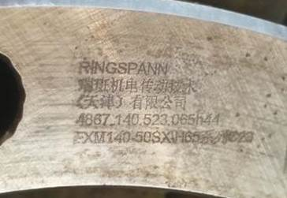

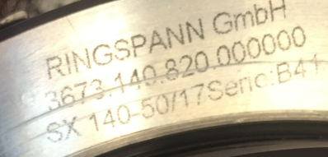

1. FXM140-50SX/H65  C23 for Tag Machine 414BE07.



