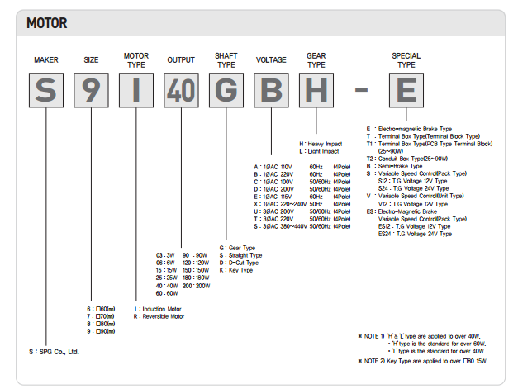

S 7 R 15 G X L – E

|  |  |  |  |  |  |  |  |
| --- | --- | --- | --- | --- | --- | --- | --- |
| Size | Motor Type | Output | Shaft Type | Voltage | Gear Type | Special Type |  |
| 70 mm | Reversible | 15W | Gear | 220-240V | Light  Impact | Electro Magnetic Brake |  |